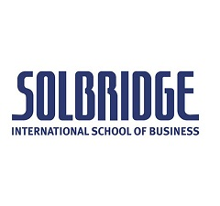
INTERNATIONAL BUSINESS PLAN COMPETITION

organized by

SolBridge International School of Business
Daejeon, South Korea

BACKGROUND
The International Business Plan Competition (IBPC) is an annual event, organized by SolBridge, in which undergraduate students from leading universities around the world are invited to the heart of Silicon Valley of Korea, Daejeon city.

Students are given a real-world scenario of leading Korean multinational company and expected to develop in-depth analysis / recommendation for a specific product or service of the company under given circumstances.

TIME AND VENUE
The program will be held during October 21th - 27th 2018 at SolBridge International School of Business, located in Daejeon, South Korea.

REGISTRATION
send your CV and letter of motivation to: sona.galanova@euba.sk
by September 20, 2018.

more info: https://euba.sk/student/oznamy-pre-studentov/1415-international-business-plan-competition-2018 or sona.galanova@euba.sk, Room A3.09

