International scientific conference
Hotel SOREA REGIA
Hotel SOREA REGIA is located at Kráľovské údolie 6, 811 02 Bratislava, Slovakia (GPS: E 17° 5' 7" N 48° 8' 39). It is easily reachable from the city center by car or by public transport to the bus stop Park Kultúry (buses no.28, 29, 30, 31, 39 and trams 4, 5, 6, 9).
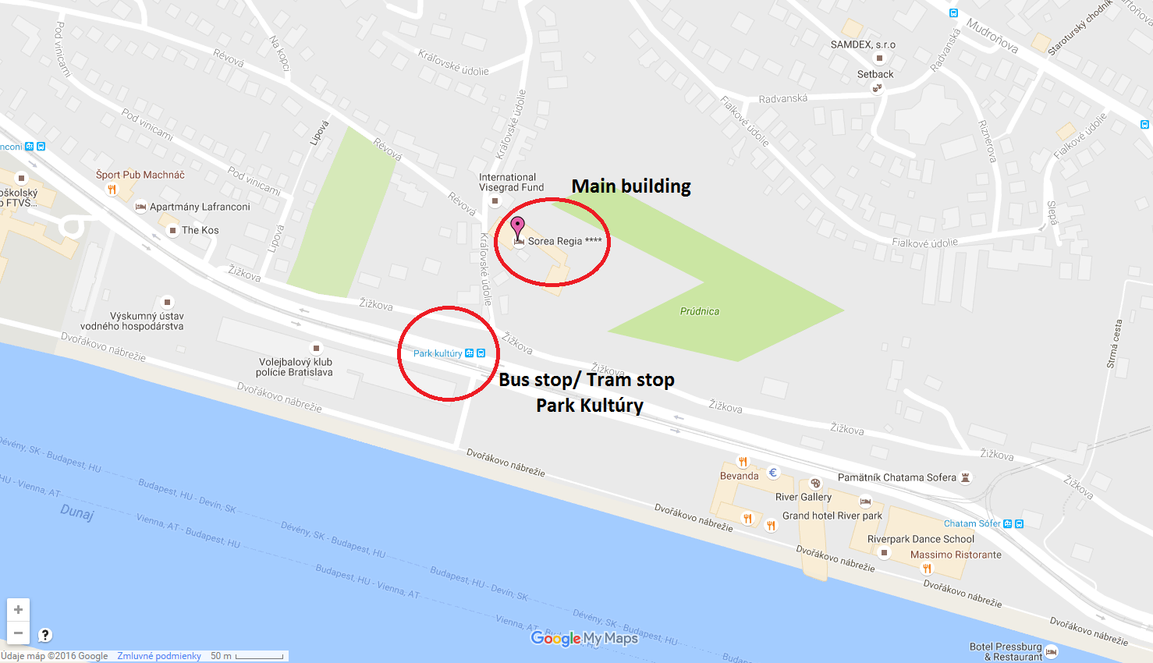
DIRECTIONS
How to get to the Hotel SOREA REGIA?

From the Bus Station (Autobusová stanica/ AS Mlynské Nivy) take bus no. 70 (direction Most SNP) and get off at 3rd stop Most SNP (walk between platforms of the stop Most SNP 3 min). Then take tram no. 4 (direction Dúbravka) and get off at 2nd stop Park kultúry
or
from the Bus Station take trolleybus no. 212 (direction ŽST Železná studienka) and get off at 3rd stop Kollárovo nám (walk between platforms of the stop Kollárovo námestie 5 min). Then take bus no. 39 or 31 (direction Cintorín Slávičie údolie) and get off at 3rd stop Park kultúry.

From Airport (Letisko) take bus no. 61 (direction Hlavná stanica) and get off at stop Račianske mýto (an approx. 22 min. ride). Walk between platforms of the stop Račianke mýto take 4 min. Then take bus no. 31 (direction Cintorín Slávičie údolie) and get off at 6th stop Park kultúry
or
from Airport take bus no. 61 (direction Hlavná stanica) and get off at stop Račianske mýto (an approx. 22 min. ride). Walk between platforms of the stop Račianke mýto take 4 min. Then take bus no. 39 (direction Cintorín Slávičie údolie) and get off at 6th stop Park kultúry.

From the Central Railway Station (Hlavná stanica) take bus no. 93 (direction Petržalka, Vyšehradská) and get off at 3rd stop Zochova. Then take bus no. 31 (direction Cintorín Slávičie údolie) and get off at 2nd stop Park kultúry
or
from the Central Railway Station (Hlavná stanica) take bus no. 93 (direction Petržalka, Vyšehradská) and get off at 3rd stop Zochova. Then take bus no. 39 (direction Cintorín Slávičie údolie) and get off at 2nd stop Park kultúry.

From City Centre (departure at bus stop Hodžovo námestie) take bus no. 93 (direction Petržalka, Vyšehradská) and get off at 1st stop Zochova. Then take bus no. 31 or 39 (direction Cintorín Slávičie údolie) and get off at 2nd stop Park kultúry
or
from City Centre (departure at bus stop Zochova) take bus no. 31 or 39 (direction Cintorín Slávčie údolie) and get off at 2nd stop Park kultúry.

From Petržalka Railway Station (ŽST Petržalka) take bus no. 93 (direction Hlavná stanica) and get off at 4th stop Zochova (walk between platforms of the stop Zochova 2min.). Then take bus no. 39 (direction Cintorín Slávičie údolie) and get off at 2nd stop Park kultúry
or
from Petržalka Railway Station take bus no. 91 (direction Most SNP) and get off at 3rd stop Most SNP (walk between platforms of the stop Most SNP 3 min.). Then take tram no. 4 (direction Dúbravka) and get off at 2nd stop Park kultúry.

How to get from bus stop/ tram stop Park kultúry to the Hotel SOREA REGIA?

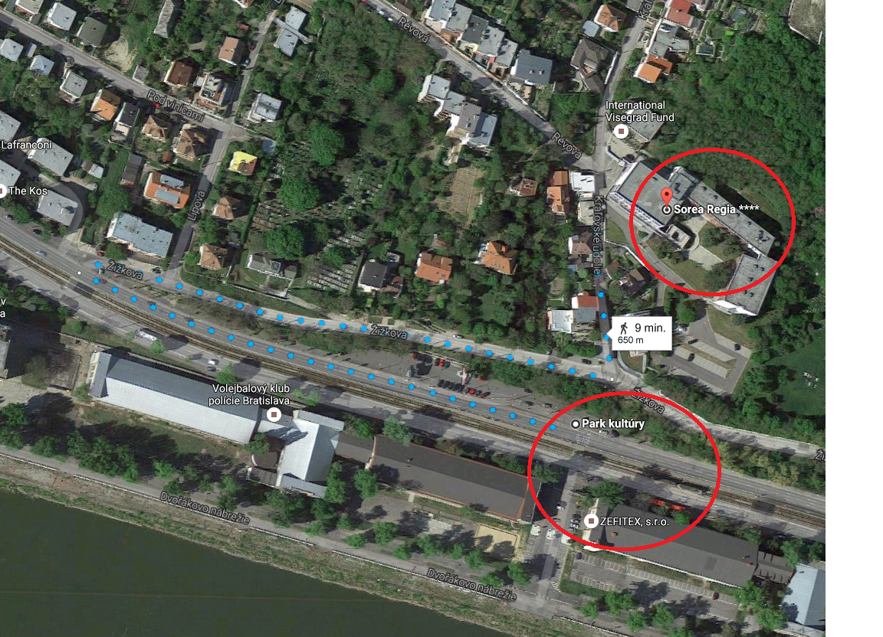

How to get to Bratislava?
Airlines and Airports
If you want to fly to Bratislava, you can choose between the city's own international airport and Schwechat airport in Vienna, which is about 70 km from Bratislava and connected by regular shuttle buses. Bratislava's airport is the biggest in Slovakia and one of the fastest expanding in Europe. Regular flights link it to other Slovak cities and with many major European destinations.
A city bus service, number 61, connects the airports to the main railway station and onward connections to the city center. By car, it normally takes 15 minutes to reach the center of town.

Auto Travel and Car Rental
Bratislava is connected to neighboring capitals by international multilane highways. Within Slovakia, the D1 motorway connects Bratislava to the east of the country and the D2 motorway connects Bratislava with Hungary to the south and the Czech Republic to the north. These roads also form part of international routes E58 (to Austria) and E65 (to Hungary and the Czech Republic). The D1 and D2 motorways are linked in Bratislava by a partial ring road on the south (Petržalka) side of the River Danube. Traffic jams on the ring road are rare and it is the fastest way to get from one end of the city to the other, especially if you are unacquainted with the inner-city traffic system. Most major international car rental companies have offices in the city, some with branches at the airport. There are also several local companies offering car rental at competitive rates.

Rail Travel
Trains in Slovakia are the safest and most agreeable way to travel throughout the country. International trains to Bratislava's main railway station run from Vienna (1 hour), Budapest (3 hours), and Prague (4-5 hours) several times a day. There are less frequent direct connections to Berlin, Bucharest, Kiev, Moscow and Warsaw. The main railway station is a short distance from the center and there is a regular tram connection; alternatively, walking takes 15-20 minutes. Trains from Vienna also arrive at Bratislava–Petržalka station, which is to the south of the city center across the Danube River. Timetable information can be obtained from the website: http://www.zsr.sk/slovensky.html?page_id=123.

Public Transport in Bratislava
Most sights and places of interest to tourists can be found in the city centre, or within walking distance of the pedestrianized old town. If you need to travel further afield within the city, the best way to do so is by public transport. Bratislava has a comprehensive network of public transport lines running at regular intervals according to defined timetables. Departure times and a list of destinations, with the journey time to each, are posted for each service at every stop it serves. Public transport in Bratislava (MHD) is run by the public transport authority, DPB, which operates bus, tram and trolleybus lines whose last departures from terminal stops are at about 23:00 (11pm). The first services in the morning normally start at about 04:20 (4.20am). Between 23:30 (11.30pm) and 05:00 (5am), several night bus services (their numbers are prefixed with an 'N') operate in Bratislava, most of them starting at the main railway station. To use any public transport service in the city, you must validate a pre-purchased ticket upon boarding by inserting your ticket into one of the red devices found on board each vehicle. Tickets are available for different zones, however for travelling in the city of Bratislava following tickets are applicable:
- a 15-minutes, multi-ride journey (0.70€)
- a 30-minutes, multi-ride journey (0.90€)
- a 60-minutes, multi-ride journey (1.20€)
- 24 hours (3.50€)
- 72 hours (8.00€)
If you are travelling with a large bag it needs a (reduced-fare) ticket too. Reduced 15-minutes ticket is valid 3 hours. Tickets can be bought from newspaper kiosks and shops, and from the yellow coin operated machines located close to many stops. Passengers must stamp their ticket in the nearest stamping machine. A ticket that has not been stamped is not valid. A passenger who cannot provide a valid ticket to the inspector will have to pay a fine in accordance with the currently valid public transport regulation. For more information about the public transport and timetable information go to: www.dpb.sk or www.imhd.sk.

Taxi Service
Bratislava has about 20 separate taxi firms with over 2,000 vehicles and at least one hundred additional drivers who are not signed up with any firm. Taxis that carry a sign with the name of a taxi service are generally a cheaper and safer option than unmarked cars with only a yellow taxi light on the roof.
Recently, a smartphone application named Hopin has gained in popularity - it is worthwhile to use it if you are staying in Bratislava for more than a few days. Hopin allows you to order a taxi without making a phone call - you can see taxis on a map, rate drivers and communicate with them via text chat.
Approximate total prices (depend on whether the taxi was ordered by phone, hailed in the street or picked up at a taxi stand, whether it is signed up with one of the companies or independent). It is cheaper when you dial in the taxi service to order a car, rather than to stop a car that you see on the street (they have a higher rate). You can save up even half of the price sometimes this way.
Approximate journey time and total prices by taxi:
Bratislava Airport to City Centre - from about 8 € for telephone ordered local taxi up to15 € flat rate charged by official Airport taxis or some hotels taxi. Journey time about 15 - 20 min.
Vienna Airport to City Centre - about 65 € to 80 € by Austrian taxi company is a reasonable price. Journey time about 45-55 min (depends on traffic).
Within the City Centre - about 3 € to 6 € for telephone ordered local taxi, up to 10 € for a taxi stopped on the street or at taxi stands. Journey time is about 10 to 15 min. (depends on traffic)
Main Train Station to City Centre - about 3.50 € for telephone orders. Journey time is max. 10 min.
Main Coach Station to City Centre - about 3.50 € for telephone orders. Journey time is max. 10 min.
Petržalka (conference venue) to City Centre – about 5 € for telephone orders. Journey time is max. 15 min.
Recommended companies including companies with fix price for ride:
Easy Taxi Bratislava: +421 918 555 555 – fixed price of one drive 5 € including downtown and Petržalka (conference venue area)
Fun taxi: +421 2 16777, +421 2 16333, +421 2 16016
Trend Taxi +421 2 16 302
VB Taxi: +421 17 158, +421 18 158

