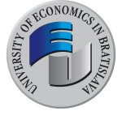
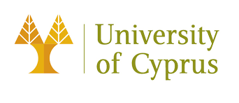

Erasmus+ KA2 D-COLLAB project consortium
and the coordinating institution
The University of Economics in Bratislava
would like to invite you to

D-COLLAB
Final Dissemination Project Conference

Methodological and Technological Aspects of Digital Teaching and Learning

Which will take place on: 15th February 2023

Venue: University or Economics in Bratislava, Dolnozemská cesta 1, 852 35, Bratislava, Slovakia
Conference room, Building V1

The conference is organized to present and disseminate the results of the project “Collaboration for Effective Digital Education” (D-COLLAB) implemented within the Erasmus+ scheme KA2– Cooperation for innovation and the exchange of good practices, KA226–Partnership for Digital Education Readiness.

The D-COLLAB team will present the outputs and key findings of the project to increase the digital readiness for online learning and teaching. Special attention will be paid also to effective methods and technical tools in the digital learning environment. The event is also to serve as a discussion forum. The participants are encouraged to share their own experience with digital teaching and learning.

Join us for this networking and knowledge sharing event to exchange knowledge, ideas and open up new cooperation opportunities!

Note:
The attendance of the event is Free for All Participants.
The participation includes refreshments during coffee breaks.

The conference is planned for the whole day (9.00-15.30).

The Number of Participants is Limited, Register Now!

All participants are required to fill in a registration form, which is available HERE

